Suggested verbiage for the Presentation

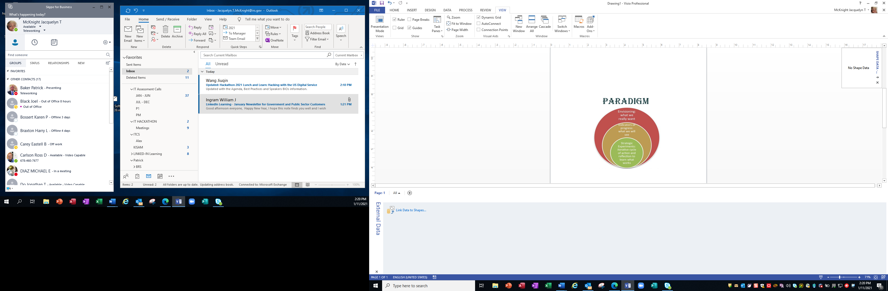

What / Why Decommission?

*What*: Identify systems

*Why*: To reduce overall costs of the IT Landscape

* High Maintenance
* Licensing costs
* Fund new innovative technologies or projects
* To support the bottom line
* Simplify Activities
* Compliance with legal/audit requirements

Impacts of Decommissioning

* Data extraction
* Access to data
* Complexity
* High TCO
* Decommissioning Strategy
* Formulation of the Order in which systems will be decommissioned
* Stakeholders
* Users
* Vendors

The prototype focuses on an “intuitive interface” that does not need much explaining; users can figure out how it works as soon as it is fired up. An Intuitive interface works the way users expect it to, and it has real advantages:

* Create happy users
* Require less training and support